Pinball Table Design Document

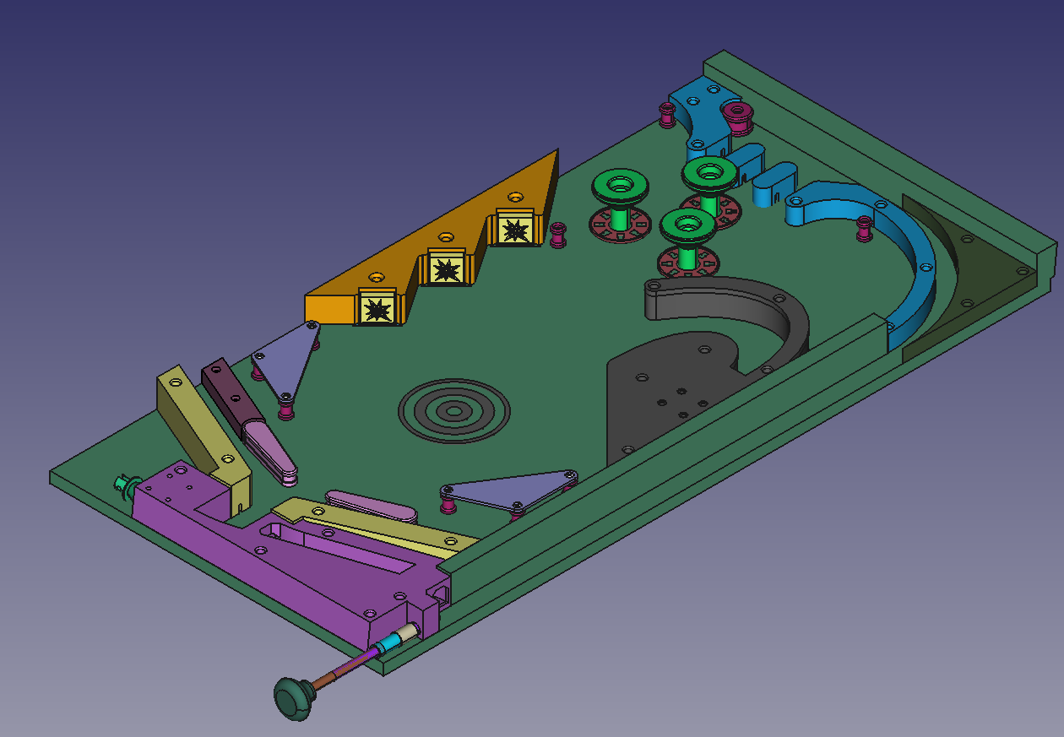Figure 1: Overall board layout

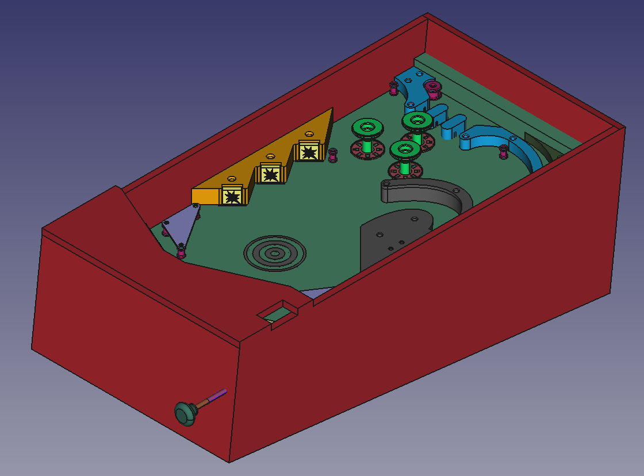Figure 2: Board layout with box

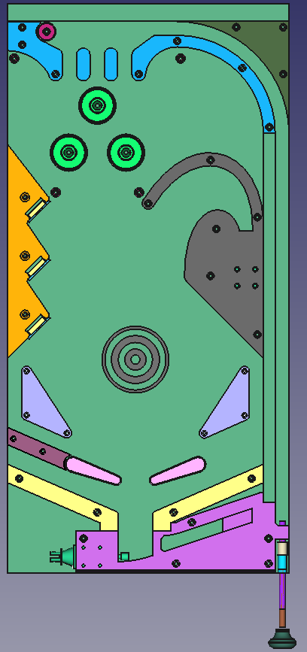Figure 4: Layout (Top View)

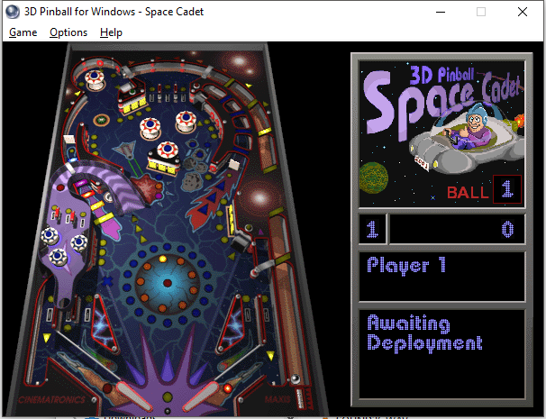Figure 5: Space Cadet Pinball

The game is loosely based off of Space Cadet 3D Pinball, shown above. Color schemes may match loosely or closely.

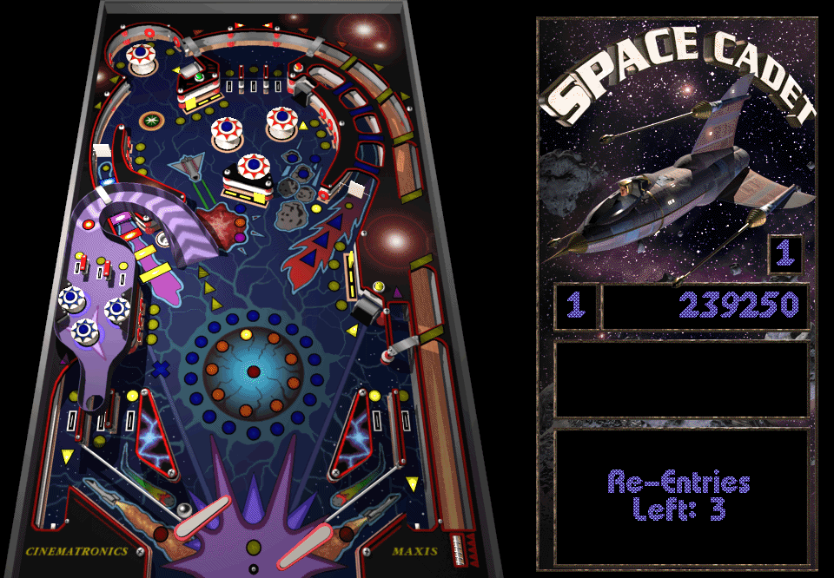Figure 6: Full Tilt Pinball Space Cadet

3D Pinball for Windows was based off of Full Tilt Pinball by Maxis, pictured above. The board layout is the same, but resolution of this image is higher, as the game ran at a higher resolution.

Figure 7: Space Cadet Pinball Table Components

Space Cadet pinball had the above components. Not all components are identical for this project, though some are similar and the naming scheme used will match.

Overall Design Guidelines

* Lights should have a location specified on the playfield drawing. Exact locations do not matter aside from the central circular light array (rank lights/progress lights in Space Cadet). Lights are circular unless noted. Exact size does not matter much, but 3/8” to 1/2” is ideal as the actual LEDs used will be small. The LEDs will shine through the drawing or have a cutout if this does not work.
* Available light colors are: white, ruby red, royal blue, emerald green, rose pink, and RGB. RGB lights should be used sparingly, as the coding and wiring is more complicated. Non-RGB lights used will most likely be these: <https://www.adafruit.com/product/3377>, mounted within a diffuse clear plastic.
* The playfield drawing will have the sticky side up attached to the underside of a thin (1.5mm) plexiglass sheet. Underneath the drawing is the ½” wooden table. The drawing should stick to the plexiglass rather than the wood if possible so that holes can be drilled in the wood without interfering with the drawing.
* Locations of objects on the physical table may differ slightly from the CAD model, so prefer soft edges around playfield fixtures, so if the fixture is slightly off it will not be noticable.
* The overall table is 1’ wide by 2’ tall, but the decal created should be slightly larger than this so no hard edges are visible. The decal will be cut to fit after installing.

Playfield Components

Flippers

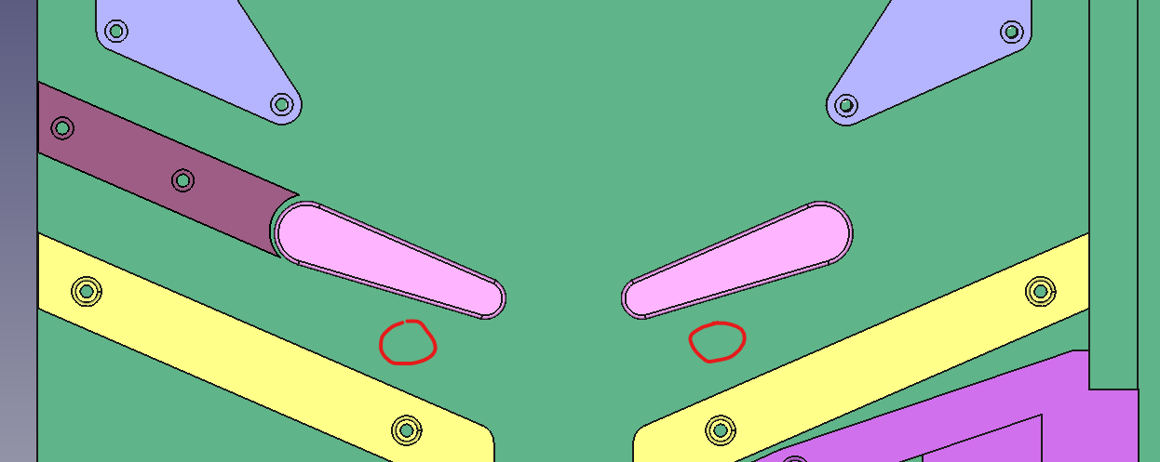The flippers should have a light underneath each, similar to the Redeploy Light and Replay light in Space Cadet. The Center Post and Center Post light from Space Cadet are ommitted.